In 2020, Sites & Cités was one of the winners of the call for proposals “Clés en Mains” from the French Ministry of Foreign affairs for a project built in link with partners in Albania and North Macedonia Republic : « Knowledge, Preservation and Promotion of old centres in Albania and North Macedonia Republic »

In the 3 countries, 18 local authorities have committed themselves to the project, with their associated partners like the Albanian and North Macedonian Ministry of Culture, ZELS Association in North Macedonia and heritage and urban planning experts in the 3 countries:
- France (6) : Beaulieu-lès-Loches, Calais, Elbeuf, La Réole, Périgueux, Reims.
- Albania (2) : Berat, Elbasan
- North Macedonia (8) : Berovo, Bitola, Kavadarci, Kratovo, Kumanovo, Ohrid, Stip, Veles
For an initial period of two years – 2020-2021 – this project pursues a three-fold objective of knowledge, protection and promotion of heritage, which will result in a transversal work associating tools of Heritage and Town Planning, raising awareness of citizens and elected representatives and the promotion of involved territories.

Axes of the Project
- Exchanges times between North Macedonia, Albania and France: they will improve the sharing of experiences between 3 countries, will initiate collaborative working methods for Heritage and will reinforce the skills of professionals and engaged partners (study trips, workshops, training courses, seminary).

- Project deliverables: Sites & Cités will support Albanian and Macedonian territories in the realisation of tools of Heritage management, preservation and promotion tools. They will allow the experimentation of new approaches that could afterwards be deployed at a larger scale (heritage inventory, tools and actions of interpretation, heritage signage). Working groups will gather regularly to exchange about the deliverables realisation.

- Communication actions: they will valorise the project and the involved actors, will raise awareness among inhabitants of Heritage and international opening.

Objectives of the Project

The project, adapted to the two countries, focuses on supporting local authorities and partners, strengthening the skills of elected officials and technicians, creating tools for the preservation and enhancement of heritage and structuring exchanges at regional, national and international levels.
The participating French local authorities face similar challenges as the Albanian and Macedonian territories: valorisation of heritage and territories, revitalisation of cities, link between heritage preservation and urban projects...
Therefore, the project wishes to encourage the sharing of experiences and expertise that will benefit all participating partners.

The project will thus make it possible to:
- Launch concrete actions, by setting up operational tools that can be used as a basis for larger-scale projects
- Strengthen the skills of actors in the field of heritage management, preservation and promotion
- Share experiences with an international network of multidisciplinary actors and facilitate the implementation of decentralised cooperation projects
- Strengthen the mediation of the local population to the heritage and to the international opening
- Facilitate the international mobility of the participants in the project, during the various Franco-Albanian-Macedonian exchanges
- Offer an external view to the participants, enriching their respective practices
- Benefit from an international visibility for a project awarded by the French Ministry of Foreign Affairs
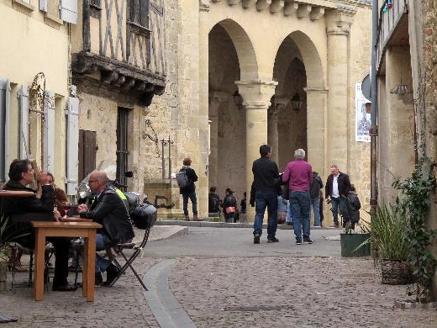
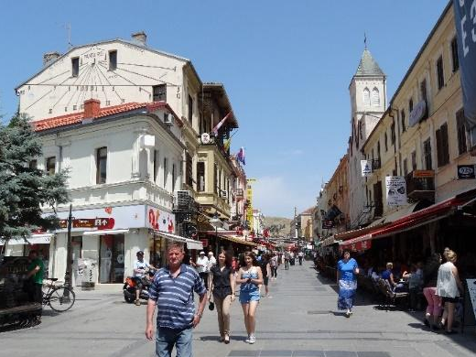
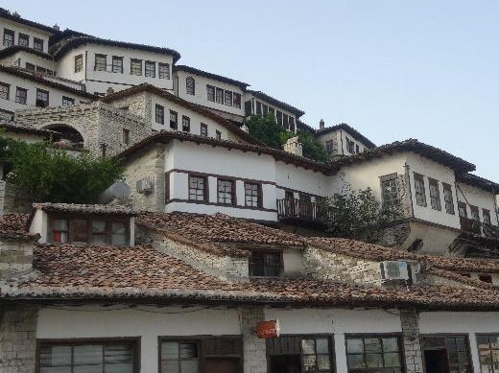
Berat, Albania
La Réole, France
Bitola, North Macedonia

